Business Plan
<Business Name>

Date

Business owner names
Business address
Business address
Business address

Email
www.businessname.com.au

Table of Contents
1. Executive summary 4
2. Business overview 6
2.1 Business Concept. 6
2.2 Style 6
2.3 Menu 6
2.3.1 Breakfast menu 7
2.3.2 Lunch menu 7
2.3.3 Sweets menu 8
2.3.4 Kids lunch box meals: 8
2.4 Drinks 8
2.5 Venue 8
2.5.1 Food preparation 8
2.5.2 Drinks 9
2.5.3 Dining 9
2.6 Location 9
2.7 S.W.O.T. 10
2.8 Legals, regulation, insurances and compliance 11
2.9 Business management 11
2.10 Team 12
2.11 Opening hours 12
3. The Numbers 13
3.1 Pricing 13
3.2 Start-up costs / project costs 13
3.3 Business growth targets 14
3.4 Projections: Profit and Loss 14
3.5 Break even 15
3.6 Loans and financing 15
4. The Market. 16
4.1 Target markets 16
4.2 Mt Gambier, information 16
4.3 Competition. 16
4.3.1 Metro Bakery & Cafe 16
4.3.2 Presto eatery 17
4.3.3 Melzar Cafe 17
4.3.4 Sorrento’s Cafe 17
4.3.5 Conclusions 18
5. Marketing and Sales 19
5.1 Overview 19
5.2 Marketing Initiatives – retail 19
5.2.1 Internet marketing 19
5.2.2 Social media 19
5.2.3 Advertising 19
5.2.4 Sponsorship 20
5.3 Website 20
6. Additional information 22
6.1 References 22
6.2 CV 22
6.3 Projections, P&L. detail 23
6.3.1 Year 1 and assumptions 23
6.3.2 Year 2 25

- Executive summary
The <Business Name> is a proposed new business, a café that will operate in Mt. Gambier, South Australia. It will be a small - medium sized cafe that incorporates a rustic, country feel with high quality tasty food that appeals to a country family clientele. To broaden the appeal to this clientele, a natural outdoor play space for children overlooked by a large decking, so parents can monitor their children but can still enjoy a relaxed cafe lifestyle.
Menu
<Business Name>’s menu will focus on tasty, consistent food with a modern twist that appeals to Mt Gambier clientele. We intend to service breakfast and lunch. Eat-in sales are anticipated to be 80%, take-away 20%. The Cafe will sell pre-made breakfast and lunch meals, items to sit-in and to go and would also offer a small table menu cooked fresh for breakfast and lunch. There will be some foods pre-made in the front display fridge for ease of take away on the run clients and then freshly made for eat in clients.
Venue
Business owners are currently negotiating for purchase of venue at xxxxx St, Mount Gambier. This business is currently registered as xxxx, a combined café and plant nursery. This venue will require complete renovation.
There will be a dedicated kitchen that will sit behind the front counter. The lunch menu (dine in) will be prepared and served out of the kitchen. The take away option will be displayed in the front fridge cabinet which will be served fresh or toasted; which will be prepared out the front where we will have a large sandwich press on the back bench behind the counter.
An application for liquor license will be submitted, with a view to serving a limited range of wines, beers and basics with lunch.
Start-up costs
Estimated start-up cost for <Business Name> is $xxx for the business and $xxxxx for the property.
Projections: Profit and Loss
A summary of financial projections is shown below.
 | Year 1 | Year 2 | Year 3
Revenue | xxx | xxx | xxx
Cost of Sales | xxx | xxx | xxx
Gross Profit | xxx | xxx | xxx
Total Costs | xxx | xxx | xxx
Operating profit | xxx | xxx | xxx

Value proposition
<Business Name> will be a unique and compelling offering in Mt Gambier, as competitors do not offer child friendly due to space and set up which is why we have a high advantage with our plans. The competitor cafes also don't appeal to many elderly as the noise and atmosphere of these cafes is unsuitable to this demographic. The food selection across the competitors also does not reach out and appeal to the elderly and we plan to offer more "homely" type meals.
Marketing initiatives will include internet marketing, social media, advertising and sponsorship

- Business overview
  - Business Concept.
The <Business Name> is a proposed new business, a café that will operate in Mt. Gambier, South Australia.
  - Style
The <Business Name> will be a small - medium sized cafe that incorporates a rustic, country feel with high quality tasty food that appeals to a country family clientele. To broaden the appeal to this clientele, a natural outdoor play space for children overlooked by a large decking, so parents can monitor their children but can still enjoy a relaxed cafe lifestyle.
The café will be designed in a rustic, country feel with some greenery and art both inside and out. The price range will be in the mid-range.
Designs have not yet been completed, however the feel of the café is shown in the following mood images.
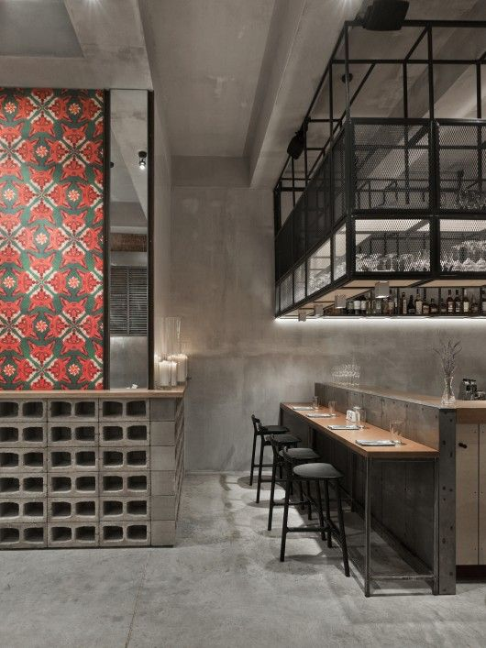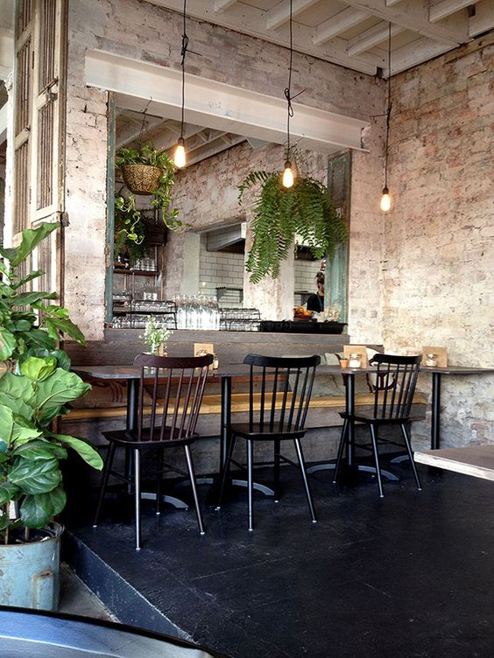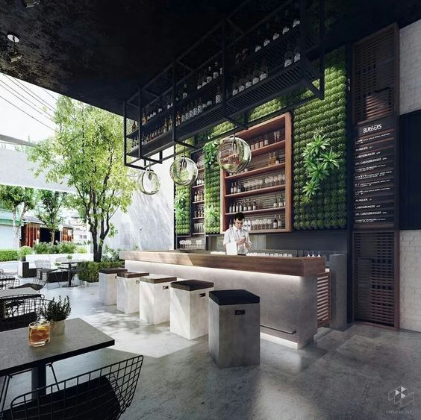
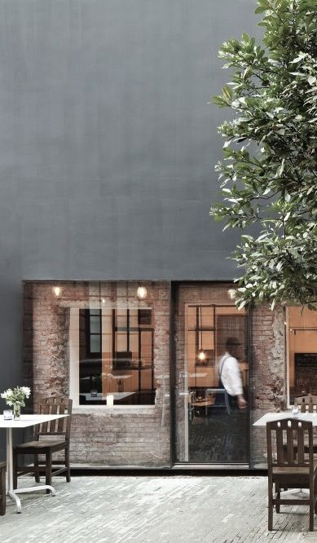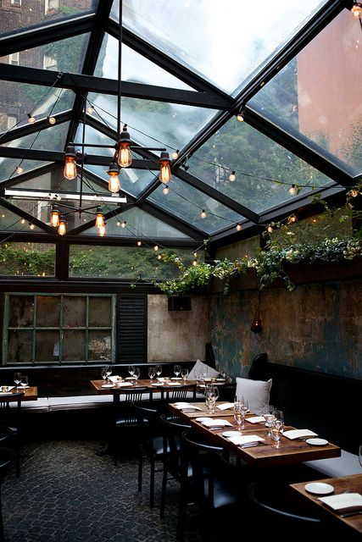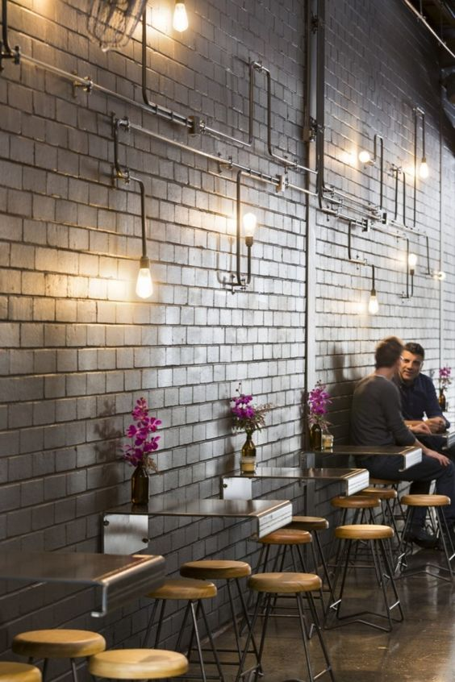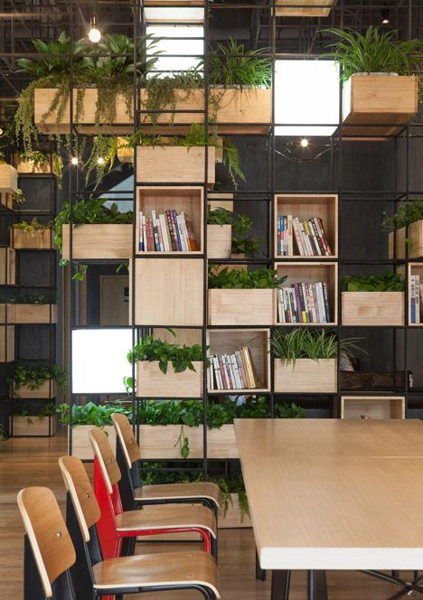
  - Menu
<Business Name> ’s menu will focus on tasty, consistent food with a modern twist that appeals to Mt Gambier clientele. We intend to service breakfast and lunch. Eat-in sales are anticipated to be 80%, take-away 20%. The Cafe will sell pre-made breakfast and lunch meals, items to sit-in and to go and would also offer a small table menu cooked fresh for breakfast and lunch. There will be some foods pre-made in the front display fridge for ease of take away on the run clients and then freshly made for eat in clients.

    - Breakfast menu
From the counter  - House made muesli with yoghurt and berries  - Spinach, avocado and feta wrap  - Plain croissant  - Ham and cheese croissant  - Ham, cheese and tomato toasted sandwich  - Bacon and cheese bagel with mayo  - Bacon, egg and cheese muffin  - Fruit bread | From the kitchen  - House made toasted muesli w your choice of yoghurt or milk  - Berry Nutella crepes w fresh cream  - <Business Name> pancakes w nuts, blueberries, topped with maple syrup and cream  - Eggs your way (2) w toasted sourdough  - The Big Breakfast (eggs your way (2) w your choice of 3 sides)  Sides:  - Crispy Bacon, Chorizo, Ham, Kale & Potato rosti, Haloumi, Tomato, Spinach, Avocado, Mushrooms and House made baked beans  Sauces:  - Tomato, BBQ, HP, Hollandaise, Aioli and Maple syrup)  - The Toast Bar (Your choice of sourdough, Multigrain, White, Wholemeal, Gluten free or Fruit loaf – served w local butter and a spread of your choice)  Spreads:  - Vegemite, Smooth peanut butter, Crunchy peanut butter, Honey, Raspberry Jam, Strawberry Jam, Marmalade and Nutella
    - Lunch menu
From the counter  - Pesto chicken w spinach, parmesan and light mayo panini  - Roast beef w rocket, tom, cedar and Dijon mayo Panini  - Tandoori chicken w spinach, red onion and spiced yoghurt panini  - Ham w fresh tomato cheddar and aioli sauce panini  - Chicken w spinach, avocado and mayo Panini  - Roast beef w spinach, cheddar and onion jam panini  - Roasted pumpkin w pocket, red onion, haloumi and relish Panini  - Chicken Caesar salad w lettuce, bacon, egg, croutons dressed with Caesar sauce  - Roast beef salad w roasted capsicum, red onion, fresh tomato w Dijon mustard dressing  - Roasted pumpkin and couscous salad w spinach and pine nuts w lemon vinaigrette dressing | From the kitchen…  - House made soups (2 options: 1 x vegetarian, 1 x other)  - Roasted sweet potato, pumpkin and pinenut salad w spinach and feta topped with a twisted lemon dressing  - Beef and Guinness pie topped w pastry and served with a side of mash or sweet potato chips  - Traditional Italian pizza w fresh tomato, bocconcini and basil  - Fresh chorizo penne w tomato, rocket and feta  - Classic beef burger w American cheddar, fresh tomato, lettuce, red onion w garlic aioli and tomato relish served on a brioche bun (served w a side of sweet potato chips)  - Thai style chicken burger w Asian slaw and authentic house sauce on a brioche bun (served w a side of sweet potato chips)  - The Big Cheese sandwich w chargrilled haloumi, sweet pickle red onion, rocket and tomato relish served between garlic Turkish roll (served w a side of sweet potato chips)  - Fish & Chips: lightly battered flathead served with a wedge of lemon, side salad and chips
    - Sweets menu
All sweets will be on display  - Slices (different flavours such as; mint, lemon, mars bar, chocolate)  - Brownie (flourless and double choc)  - Muffins (double choc, choc chip, white chocolate and raspberry, orange and poppy seed, apple and cinnamon and banana)  - Cake (All varieties)  - Banana and caramel pie  - Hummingbird cake | - Scones (plain, pumpkin, date)  - Biscuits (all different flavours)  - Chocolate tart topped with fresh raspberries
    - Kids lunch box meals:
- Mini cheese burger (or slider) + Vegie sticks or fruit + Biscuit or half slice
- Mini pizza + Vegie sticks or fruit + biscuit or half slice
- Mini Panini + Vegie sticks or fruit + Biscuit or half slice
- Grilled chicken + Vegie sticks or fruit + Biscuit or half slice
- Lasagne + Vegie sticks or fruit + Biscuit or half slice
- Quiche cup + Vegie sticks or fruit + Biscuit or half slice
  - Drinks
- Full range of coffees, teas, chocolate, etc. A skilled barista will be employed to ensure quality coffee is a drawcard for the business
- Full range of bottled drinks
- Freshly made smoothies, juices, milkshakes and thick shakes
- Alcohol – Selection of wines, bottled beer, ciders, basic spirits
  - Venue
Business owners are currently negotiating for purchase of venue at xxxx St, Mount Gambier. This business is currently registered as xxxxxx, a combined café and plant nursery. This venue will require complete renovation.
    - Food preparation
There will be a dedicated kitchen that will sit behind the front counter. The lunch menu (dine in) will be prepared and served out of the kitchen. The take away option will be displayed in the front fridge cabinet which will be served fresh or toasted; which will be prepared out the front where we will have a large sandwich press on the back bench behind the counter.
The kitchen is likely to be compact but with an easy working space, practical and easily workable.
The Kitchen will have the following equipment:
- Electric Griddle Toaster  - Compact double pizza deck  - Under bench Glass Washer  - Steel double sink benches  - Smaller equipment like mixers, blenders, utensils etc.  - Gas 6 Burner Top On Oven with flame failure  - Toaster/ Griller/ Salamander | - Pizza Prep bench  - Steel Tables with splash back  - Ice maker  - Fridges will be in the front counter for display foods, in the kitchen for main using foods/storage and the freezers will be in the kitchen and back store room.
    - Drinks
Will be stored in an inbuilt fridge behind the counter; they will not be on show, only displayed on the menu list.
An application for liquor license will be submitted, with a view to serving a limited range of wines, beers and basics with lunch.
    - Dining
In the café, initial plans will be to have approximately 40-50 seats, comprising of window bench seats, 6-8 tables inside, 2-4 tables in front (inside property), and then about 6-10 tables out the back on the decking. An interior designer has been engaged to create an appealing, functional design.
  - Location
The proposed business location as mentioned is at xxxxxx St, one of the leading streets into Mt Gambier town, from the eastern side of town. xxxxx St is not the principle shopping strip in Mt Gambier, however is closely located and easily accessed from Main St central shopping centre (~500m away). xxxx St is walking distance to the following shops and offices within 20-500m are as follows:
- Target  - Radio rentals  - People's choice Credit Union  - Tyre centre  - Veterinary clinic  - Public Library  - Aged care equipment shop  - Fire Station  - Lawyers offices  - Podiatrist  - Government office (branch office) | - Spotlight  - Hawkins medical centre (the main medical clinic of Mt Gambier is very close)  - Chemist  - Auto shop  - Dog grooming Centre  - Aged care centre  - Ambulance centre  - Gynaecologist rooms  - Financial office  - Central caravan park ( mainly attracts retirement couples on budgets)
Due to central location, travel time from any location in Mt Gamiber City to the proposed location would not exceed 15 minutes. There is ample car parking in the surrounding streets.
Location Map 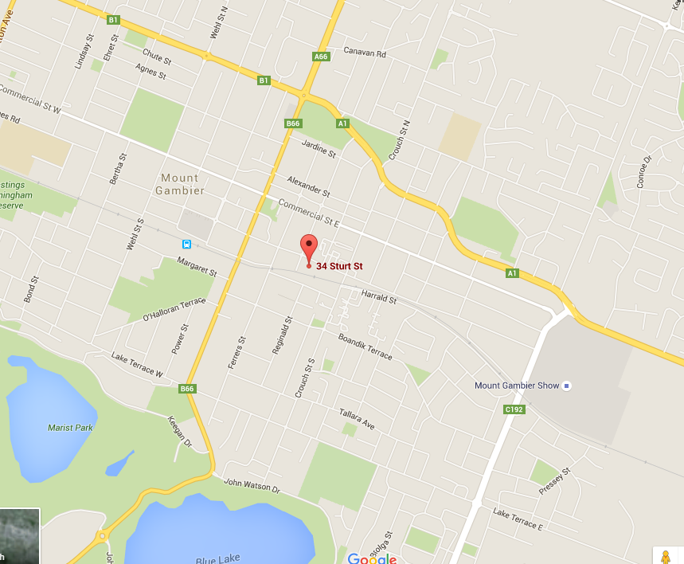
Current use

Image

  - S.W.O.T.
Strengths
- Immediate cash payment (no debtors)
- Interesting venue and menu for local area
- Attention to detail and proactivity in business owners
- Strong business planning and preparation
- Available capital
- Good local support
Weaknesses
- First time business owners, with limited experience
- Brand not known or established
- High set up costs
- Business is very dependent on owner
Opportunities
- New type of venue for Mt Gambier – will capture attention and word of mouth
- Growing population
- Growing market for café customers
- Occupation of market space as leader
- Future events venue
- Expansion into evening trade as well
Threats
- Competitors could easily move into the market and capture market share
- Economic downturn, interest rate rises and other rising costs may reduce the amount of disposable income in target market.
- Uncertainty in target market from new business.
- Unexpected costs/taxation that shock cash flow.
- Negative word of mouth
- Availability of suitable, reliable, qualified and experienced staff
  - Legals, regulation, insurances and compliance
Insurance
- <Business Name> will hold all relevant insurances, including Public Liability, Product Liability, building/contents and vehicle.
Legals
- <Business Name> will engage legal advice to create Terms and Conditions, oversee all agreements, leases, contracts and employee conditions.
Food Safety
- <Business Name> as handler of potentially hazardous food, will require registration and compliance with applicable local councils. All required permits will be complied with, in consultation with local authorities.
Occupational Health and Safety
- <Business Name> will engage expert advice to ensure compliance with all regulations.
  - Business management
<Business Name> will be managed by Business Owner, with CV’s for each owner/manager provided in Section 6.2. The combined experience of both create a solid foundation for sound business management. This includes:
- Extensive experience in customer service
- More than 10 years’ experience in food businesses, take away, hotels and catering
- High level financial and risk management experience

  - Team
<Business Name> will have a small dedicated team that will likely be composed of the following team members:
Job Title | Number | Role and responsibilities | Person
Café manager | 1 x FT  1 x PT | Manage all aspects of retail store, including ordering, customer service, stocking and presentation, staff management. | Business Owner Name
Accounts | 1 x PT | Manage all accounts, finance, payroll, taxation, reporting and compliance tasks for entire business. | Business Owner Name
Kitchen manager / chef | 1 x EFT + 1 PT  or 2 x PT | Manage all aspects of kitchen including ordering, food safety, food preparation, menu design, and staff management. | Head Chef Name
Floor staff | PT, total ~1.5 EFT | Customer service | To be hired
  - Opening hours
Tuesday – Sunday, 7.00-4.00pm is our current expectation.
- The Numbers
  - Pricing
Menu prices will be in the range $10-19 with an estimate average sale of $14.00 (ex GST).
  - Start-up costs / project costs
Detailed estimates of business start-up costs are shown below.
 | Estimated cost | Comments
Infrastructure & Organisation
Business name registration | xxx | Trading Name $25.00, Trust Setup $400.00
Company registration | xxx | Company Setup (ABN/TFN),
Accounting fees / book keeping fees - set up | xxx | Set up 2 entities for property and business
Legal fees (agreements, T&C, lease, etc.) | xxx | Solicitor
Licensing | xxx | Council Fees
Insurances | xxx | Monthly – First month
Business planning and research | xxx
Domain name registration | xxx
Pre-Purchase Evaluation of Property | xxx | Incurred cost to us, bank does not pay this fee.
Purchasing existing business | xxx
Loan costs | xxx
Office, showroom, shop
Premises - financial set up | xxx | Offer and $18,000 stamp duty (5%)
Fitout, including all renovation, signage, IT installation | xxx | Renovation $100,000 Inc. 10% builders fee, Kitchen $40,000, landscaping $10,000
Telephone system | xxx
Design / Interior decorating services | xxx | Includes design fee 5-10%
Internet, services & utilities connection | xxx | Basic
Safe/s | xxx | Estimate
Cash register/s | xxx | Kounta bundle
Office products, stationery etc. | xxx
Software - office, accounting, CRM | xxx | MYOB Essential $50.00 a month, Kounta $40.00 a month X2
Point-Of-Sale system/s | xxx | X2 IPad Air $959, IPad secure counter stand $120.00
Merchant facilities (Web / terminals / Establishment) | xxx
Coffee Machine | xxx | Monthly
Branding, Advertising & Marketing
Design - logo, business cards | xxx
Design - brochures, flyers, catalogues | xxx | Menus
Website design & construction | xxx | Well designed basic website
Signage and branded products | xxx | Graphic designer
Launch marketing | xxx
Pre-launch & Stock
Raw materials | xxx | Estimate
Stock | xxx | Estimate
Packaging | xxx | Food containers etc.
Staff & Recruitment
Job advertisement/s | xxx
Employment contract/s | xxx
Uniforms and safety apparel | xxx
Training
Industry-specific / statutory training for you | xxx | Liquor License, RSA x2, Barista course, Other food and safety courses.
Staff training | xxx | Food handling course
Self-education | xxx
 | xxx | Property
 | xxx | Business

  - Business growth targets
For the projection period, up to and including Year 3, the following numbers of daily customers are expected:
  - Projections: Profit and Loss
A summary of financial projections is shown below. For full detailed projections, please refer to Section 6.3.
 | Year 1 | Year 2 | Year 3
Revenue | xxx | xxx | xxx
Cost of Sales | xxx | xxx | xxx
Gross Profit | xxx | xxx | xxx
Total Costs | xxx | xxx | xxx
Operating profit | xxx | xxx | xxx

  - Break even
Based on these estimates the business needs >68 members to break even in the first financial year.
 | Year 1 | Year 2
Break even | xxx | xxx
Members | xxx | xxx
  - Loans and financing
Business Owner is seeking finance of $xxxx and will also invest $xxxxx of his own capital as part of the start-up funding.

- The Market.
  - Target markets
With a relatively small population, target markets for The <Business Name> will need to be broad, in order to build sufficient clientele. Projections are based on 600-800 customers/week so the café will need to appeal to a wide range of the local population and cannot afford to be targeted too tightly.
This will be achieved by providing:
- Fresh, delicious, high quality food that appeals to a broad cross section
- Menu that is contemporary but not so adventurous as to deter customers
- Friendly relaxed atmosphere
- Efficient welcoming service with no attitude
- Country in style and approach, making local feel at home, yet still enjoying café lifestyle in a Mt Gambier way
  - Mt Gambier, information
Mount Gambier has an estimated population of 26,246¹, and has seen continuous population growth of in the range 0.24%-1.22% year on year since 2003. Overall population growth in the same period is 8.69%¹.
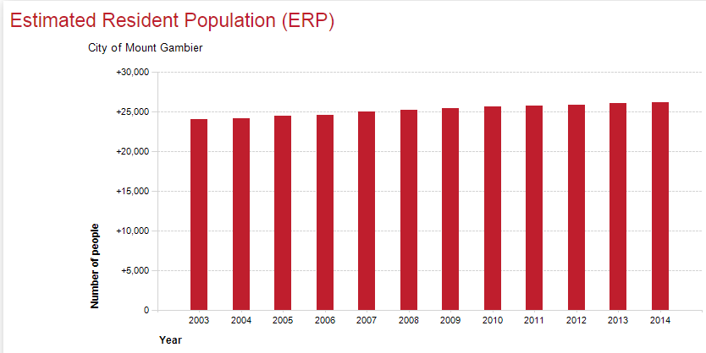

  - Competition.
There are 4 main competitors in Mt Gambier:
    - Metro Bakery & Cafe
Consists of take away bakery breads and pastries, designer cakes, breakfasts such as; classic small and big breakfasts, specialty breakfasts and then pancakes etc. Lunch menu such as; Light bites, salads, steaks, sandwiches, pastas and burgers. Drinks: coffee, shakes, bottled drinks, and alcohol
Price overview: Prices range from $9-$23 with the majority being $12-16.
Location: Their location is on the main street which has high foot traffic due to local businesses.
Details: The started off as a small bakery/cafe, and have now branched out to dinners and have a small bar now. They also offer live music on Sunday's. They are extremely busy most days and employ at least 10 front of house staff at any one time.
What they do well: They offer a large range of products and are highly convenient to foot traffic. Small bar and live music on Sunday's attracts the crowd. They also bake their own breads which is a plus in a small town.
What they don’t do well: They don't have a lot of room in their dining area so when it is busy there is very limited space to move around and becomes extremely noisy, which makes for an unpleasant experience. With the layout of their cafe it makes it hard for people getting takeaway to stand anywhere without being on top of diners. Their interior fit out is some what functional; however it is quite bland and not engaging to the customer. They also have very limit parking around them. Not child friendly at all, as not enough room. Their gourmet cakes also look like they have been sitting in their cabinets for several days.
    - Presto eatery
Presto is a take away eatery that has all foods pre-made. The range from healthy alternative breakfasts, to breakfast rolls/wraps, then have a range of healthy salads and lunch items such as frittatas, tacos, rolls, pastas etc. They also have some biscuits and muffins. Drinks: coffee, shakes, bottled drinks
Price overview: Prices range from $6-16 for the whole range of foods, which the mean being $12.
Location: They are just off the main street down a street opposite Metro and are across the road from the Cave gardens, however we have heard they will be moving to the main street to expand.
Details: They only offer pre-made food due to the owner doing catering work/events at the "Main Corner Function rooms". The owner/chef used to work at Sorrento’s Cafe. It is a very small walk in shop with a couple of tables and no table service.
What they do well: Their shop is appealing and convenient as they're across from the park and also public library. They service is quick and have a friendly team. Their food and coffee is one of the better out of the 4. They have a good car park behind them from the Pub next door.
What they don’t do well: They only offer a select range and quantity, which means a lot of product runs out quickly. They only have 2 people working in their at one time so lunch time periods when busy we waited 15+ minutes, which I believe is far too slow for food which is pre-made.
    - Melzar Cafe
Melzar's offer a large range of product for a small cafe. It ranges from vegan/paleo breakfast and lunch menus such as standard breakfasts and paleo options. Lunches range from salads to toasted rolls and burgers. Drinks: coffee, shakes, juices, bottled drinks, specialty teas. They also roast their own coffee in a separate small coffee shop which they have just recently opened and won awards for.
Price overview: Their prices ranging from $15-25.
Location: Melzar's is located behind the main street but down the opposite end to the other cafes. They are across from the main green grocers, Coles, and Bakery. They have high foot traffic due to the main shops.
What they do well: They have a nice menu and tasty food. It is all freshly cooked to order. Their customer service is quite good also.
What they don’t do well: They are a pokey cafe with a very low budget spent on it and isn't all that appealing. The table numbering doesn't work well as the girls walk around in circles trying to find table numbers. It is really only a good place to order, eat and get out. Not child friendly at all. Zero atmosphere, and their kitchen is extremely small and dirty as you can see it from the seating area.
    - Sorrento’s Cafe
The menu at Sorrento’s is extremely large, however they have 5+ chefs in the kitchen at any one time. Their breakfast menu consists of all type from small to big breakfasts, omelettes, pancakes, and waffles. Their Lunch and dinner consists of burgers, sliders, steaks, pastas, tapas, pizzas, and gourmet menu options including fish of the day etc. They have a "in between menu" which is mainly pizza, Turkish rolls, chips and wedges. they have a kids menu of fish and chips, nuggets and chips, mini pizza and also pasta. They also offer cakes and desserts in their cabinet display. Drinks coffee, alcohol, fruit whips, shakes, freshly made juices, and bottled drinks.
Price overview: Prices range from $9-40 depending on kids menu, snacks right up to the dinner steaks and specialty dishes. Breakfast and lunches range from $14-28.
Location: Sorrento’s is located just off the main street on the opposite side of the Cave gardens. This has high foot and car traffic due to its reputation and size.
What they do well:
Sorrento’s Cafe is more like a restaurant so has a lot more options on their menu and is a largest cafe in Mount Gambier. They started a steak house back in the day and then the head chef and owner of that bought the premises of Sorrento’s and started a cafe/restaurant which has always been successful due to their reputation through the steak house. They have table service which they do well at when not busy and are always friendly.
What they don’t do well: They get lazy when the head chef/owner isn't there and so service does drop. They do have a high amount of children/families that go there, however it is on the main road (Bay Road) and they always have the front bi-fold doors open so it isn't a relaxing place to go to with children as you always have to walk around after them, which then disrupts the other customers.
    - Conclusions
Overall none of the cafe's in town are child friendly due to space and set up which is why we have a high advantage with our plans.
The competitor cafes also don't appeal to many elderly as the noise and atmosphere of these cafes is unsuitable to this demographic. The food selection across the competitors also does not reach out and appeal to the elderly and we plan to offer more "homely" type meals.
Our competitors do not have the outdoor facilities that we intend to have. As we face North we offer Alfresco dining out the front and a large deck out the back overlooking maintained gardens and natural play space. This will appeal to a significant clientele and encourage sales throughout the year and especially in summer periods when customers can eat and drink in a relaxing space outside. The outdoor deck will be climate friendly with café blinds, heating and aircon for all year purpose.

- Marketing and Sales
  - Overview
Sales and marketing strategy will form a key part of the <Business Name> growth plans, with specific marketing campaigns used to build the <Business Name> brand, stimulate interest and demand and drive customers to the retail outlet.
  - Marketing Initiatives – retail
    - Internet marketing
Overview | Develop and implement a series of online marketing initiatives that utilise the internet and email.
Value | Internet marketing facilitates very broad exposure to potential clients and contact with current clients. Campaigns can be highly targeted, usually with detailed metrics available that can provide useful feedback on ROI and can be used to increase results. The potential target market is very large, with very good potential for cost effectiveness.
What’s involved | Once all of the available opportunities have been researched, specific content will be developed for each channel and a smaller trial initiated. After monitoring results, the content will be fine-tuned and/or the programs expanded.
Specifics | The following initiatives and programs will be included:  - Web traffic monitoring systems  - Internet directories – paid or free  - Advertising  - Search engine optimisation
    - Social media
Overview | Develop and implement a series of marketing initiatives based on social media platforms.
Value | Social media presents a unique marketing opportunity, with enormous numbers of potential contacts that can be reached for very low cost. This platform also enables followers to share between each other, building word of mouth and viral marketing. Followers interact more readily also, building engagement and a sense of community around the brand.
What’s involved | Once all of the available opportunities have been researched, specific content will be developed for each channel and a smaller trial initiated. After monitoring results, the content can be fine-tuned and/or the programs expanded.
Specifics | The following initiatives and programs will be included:  - Facebook  - Instagram
    - Advertising
Overview | Place advertisements in any location viewed by target market.
Value | Advertising can identify your business to potential customers when they are actively looking for a provider or the advertisement stimulates desire. Advertising has the potential to reach a very wide audience and can increase exposure, brand awareness and educate target markets about the brand.
What’s involved | After researching suitable locations to place advertisements, content will be designed and developed with professionals who can help to make the greatest impact. Once advertisements go live, results will be closely tracked.
Specifics | Advertisements will be placed as follows:  - Newspapers  - Magazines  - Newsletters  - Guides and directories
    - Sponsorship
Overview | Market to groups, events, associations and organisations through participation in their activities.
Value | Sponsorship can be a very good means of generating brand exposure, can offer cost effective marketing channels and the trust of the target audience in the organisation can be leveraged to generate good will. An identity of community support to the target audience can also be developed.
What’s involved | Research and identify the groups, schools, clubs, organisations and associations that your target market participate in. For each group, find out sponsorship opportunities and assess each for value and ROI. For those selected, plan carefully and work with organisers to maximise marketing outcomes.
Specifics | The following initiatives and programs will be included, dependant on type of sponsorship. This may include brochures, flyers, advertisements, prize donations, etc. (give details).  - Local sports groups  - Schools  - Mothers Groups
  - Website
<Business Name> create a simple website that will act as an online brochure and a central location to engage with current and future customers.
Website objectives
- Offer company information
- Direct new enquiries and reservations
- Generate sales
- Build brand awareness
- Create virtual shopfront
- Contact details

Design style
- Fresh and healthy  - Clean simple design  - Easy to navigate  - Clear product categories | - Friendly  - Informative  - Knowledgeable

- Additional information
  - References
1. Profile.ID, City of Mount Gambier Estimated Resident Population (ERP), http://profile.id.com.au/mount-gambier/population-estimate
  - CV
Business Owner’s CV

  - Projections, P&L. detail
    - Year 1 and assumptions
 |  | Year 1 | Year 1 | Year 1 | Year 1
 | Assumptions | Apr | May | Jun | Total
Sales / Revenue
Sales / Revenue | Average sale/person
 | Customers/day
 | Weekly revenue
 | Monthly revenue
Total revenue
Cost of Sales
Ingredient costs | 25% of sales
Total cost of sales | $-
Gross Profit | $-
Overheads
Accounting | $3500 plus GST Annually - includes both of our personal taxation
Bank fees | $100/month
Council fees | $2000/year
Coffee Machine | $320/month (Rent to buy or hiring)
Electricity | $500/month
Gas | $100/month
Insurance | $300/month
Interest paid | $538/week
Internet | $100/month
Marketing | 1% of revenue
Merchant fees | 1% of sales
Office supplies | $30/month
Rates | $150/quarter
Recruitment | $50/month
Repairs and Maintenance | $100/month
Staff amenities | $100/month
Telephone | $200/month
Training | $100/month
Vehicle expenses | $100/month
Waste | $100/month
Water | $150/month
Website | $50/month
Wages
Chef | $54,000/year - 1.2 Chefs average
Floor staff | $70,000/year
Owners | $100,000/year
Superannuation | 9.5%
Workcover | 1.5% of wages
Total Costs | $-
Operating profit | $-

    - Year 2
 | 2016 | 2016 | 2016 | 2016 | 2016 | 2016 | 2017 | 2017 | 2017 | 2017 | 2017 | 2017 | 2016-17
 | Jul | Aug | Sep | Oct | Nov | Dec | Jan | Feb | Mar | Apr | May | Jun | Total
Sales / Revenue
Sales / Revenue
Total revenue
Cost of Sales
Ingredient costs
Total cost of sales
Gross Profit
Overheads
Accounting
Bank fees
Coffee Machine
Electricity
Gas
Insurance
Interest paid
Internet
Marketing
Merchant fees
Office supplies
Rates
Recruitment
Repairs and Maintenance
Staff amenities
Telephone
Training
Vehicle expenses
Waste
Water
Website
Wages
Chef
Floor staff
Owners
Superannuation
Workcover
Total Costs
Operating profit

